TimberFrame2D

1. Introduction
Structural engineers rely on computational tools to analyze framed structures and verify that members satisfy code requirements. This project presents TimberFrame2D, a from-scratch 2D structural analysis and timber design desktop application developed in C# (.NET 10, WPF). The program analyzes plane frames and trusses using the linear-elastic direct stiffness (matrix displacement) method and performs timber member design to three international codes, the US/NDS method, Eurocode 5 (EN 1995), and the Turkish timber design code (TBDY).
The application accepts complete structural models, nodes, frame/truss elements with optional moment releases, materials, sections, supports, and a range of loads (nodal, uniformly distributed, point, thermal, and support settlements), through a live, editable interface. It assembles and solves the global stiffness system, recovers support reactions and nodal displacements, and reconstructs per-member axial (N), shear (V), and bending-moment (M) diagrams together with the true deflected shape. On the design side, it evaluates tension, compression, bending, shear, and combined bending-plus-axial checks, reporting demand/capacity (D/C) utilization ratios per member against code-standard load combinations with load-duration adjustment. Results are presented through a live 2D model view, internal-force diagrams, and color-coded pass/fail design tables.
The current scope is deliberately bound: the tool is two-dimensional, linear-elastic and small-displacement, and limited to timber design. These boundaries, together with planned extensions (3D rendering, steel/concrete modules, and project save/report export), are discussed in the closing sections.

2. Scope of the Software
TimberFrame2D is a 2D structural analysis and timber design application. Its scope covers:
- Analysis: Linear-elastic, small-displacement analysis of plane frames and trusses by the direct stiffness method.
- Elements: Frame (3 DOF/node) and truss (2 DOF/node) members, with optional end moment releases (hinges).
- Loads: Nodal forces/moments, member uniform-distributed loads, member point loads, thermal loads, and support settlements.
- Results: Support reactions, nodal displacements, per-member N/V/M diagrams, and the deflected shape.
- Design: Timber member checks, tension, compression, bending, shear, and combined bending + axial, to US (NDS), Eurocode 5, and Turkish (TBDY) codes, with D/C utilization ratios and a final detailed report generation (to be improved).
- Load combinations: Code-standard combinations (ASCE 7, EN 1990, TBDY) with load-duration adjustment and a per-combination design envelope.

3. Theoretical Background

3.1 The Direct Stiffness Method
The program analyses structures by the direct stiffness (matrix displacement) method, the standard matrix formulation of linear-elastic structural analysis. The governing relation for the whole structure is
K U = F
where K is the global stiffness matrix, U the vector of unknown nodal displacements (and rotations), and F the vector of nodal loads. The solution procedure is:
- Discretization and DOF numbering — each node carries up to three in-plane degrees of freedom: two translations (u, v) and one rotation (θ). Truss members use only the two translational DOFs.
- Forming the element stiffness matrices in each member’s local axis system.
- Transforming each element matrix from local to global coordinates.
- Assembling the element contributions into the global matrix K.
- Applying the boundary conditions (supports).
- Solving the reduced system for the unknown displacements U.
- Recovering the support reactions and internal member forces.

3.2 Coordinate Transformation and Assembly
Each member is oriented at an angle θ to the global X-axis. With c = cosθ and s = sinθ, a transformation matrix T rotates quantities between the local and global frames, and the element stiffness in global coordinates is
k_{global} = T^{T} k_{local} T
The global stiffness matrix is built by direct assembly: each element matrix is added into the rows and columns of K corresponding to its end-node DOFs. Because K is large and mostly zero, it is stored as a sparse matrix.

3.3 Loads and Equivalent Nodal Forces
Loads applied between nodes (distributed loads, point loads along a member, thermal effects) cannot enter F directly. They are converted to equivalent nodal loads using the member’s fixed-end forces. After solving, these fixed-end forces are added back when recovering the true member end forces.

3.4 Solving the System
Supported DOFs are removed (partitioning the free and restrained DOFs), leaving a reduced, symmetric positive-definite system that is solved for the free displacements. The program uses a sparse Cholesky / LDLᵀ factorization for efficiency. If the structure is a mechanism (unstable or under-restrained), K is singular; rather than failing, the solver detects this and reports the offending node and DOF.

3.5 Recovery of Reactions and Internal Forces
With U known:
- Reactions at supports follow from the restrained-DOF rows:
R = K U − F
- Member end forces are recovered locally as
f_{local} = k_{local} T u_{global} + f_{FE}
- Internal-force diagrams (N, V, M) along the member are obtained by statics from the end forces and the spanwise loads. Extrema are captured exactly zero locations (moment peaks) and the steps/kinks at point loads are sampled explicitly.
Sign convention: N is tension-positive and M is sagging-positive.

3.7 Deflected Shape
The deflected shape is not drawn as straight lines between displaced joints but as the true bending curve, interpolated from the nodal displacements and rotations using the Hermite cubic shape functions of the beam element:
v(x) = N₁v₁ + N₂θ₁ + N₃v₂ + N₄θ₂

3.8 Verification (Equilibrium Residual)
As an internal correctness check, the analyzer computes the equilibrium residual after the solve:
‖ K U − F ‖
A small residual confirms the solution satisfies global equilibrium; a large one raises a warning.

3.9 Timber Design Theory
After analysis, members are checked against code limit states. The demand on each member is taken from its station envelope, the worst section force anywhere along the span, not merely the end values.
Strength checks. For each member the design (or allowable) stress is compared against capacity, expressed as a demand/capacity (D/C) utilization ratio (≤ 1.0 = pass):
- Axial tension: σ_{t} = N/A ≤ f_{t}
- Axial compression (with column-stability reduction): σ_{c} = N/A ≤ k f_{c}
- Bending: σ_{m} = M/S ≤ f_{m} (with a lateral-torsional stability factor where applicable)
- Shear (rectangular section): τ = 3V/2A ≤ f_{v}
- Combined bending + axial (an interaction equation, e.g. for compression + bending).
The exact form follows each code’s interaction rule.
Load-duration and modification factors. Timber strength depends on how long the load acts and, on the moisture/service condition. Each code applies a corresponding factor to the reference strengths:
- Eurocode 5: k_{mod} (load-duration × service class), with material partial factor γ_{M}.
- US / NDS: load-duration factor C_{D} (and other adjustment factors C_{i}).
- Turkish (TBDY): the equivalent load-duration factor λ.
Load combinations. Demands are evaluated for code-standard combinations, ASCE 7 (US), EN 1990 (EC5), and TBDY, each combining dead, live, wind, etc. with the appropriate partial / combination factors. The governing case per member is selected via a design envelope across all combinations, and the load-duration factor is applied per combination according to its shortest-duration leading action.
This document describes the software architecture of the TimberFrame2D package: how the projects are organised and connected, the data flow through the application, the object-oriented design patterns used, and the major design decisions behind them.

4. Software Architecture

Solution structure
The solution is split into seven projects along clear responsibility boundaries. Dependencies flow in one direction only, from presentation down to the domain, so the computational engine has no knowledge of the user interface.
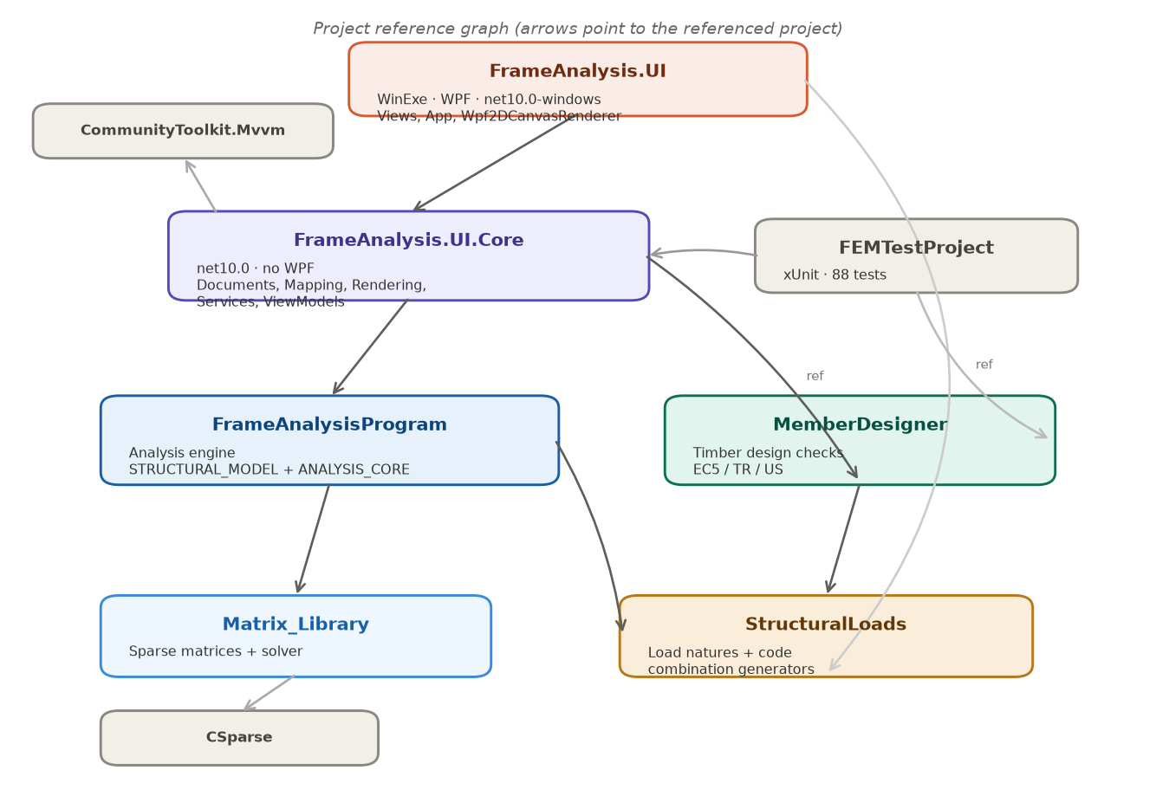
Figure 1 — Project reference graph (arrows point to the referenced project).

Project | Target | Responsibility
Matrix_Library | net10.0 | Sparse matrices and the linear solver (wraps CSparse).
StructuralLoads | net10.0 | Load natures, limit states, and code load-combination generators (ASCE 7 / EN 1990 / TBDY).
FrameAnalysisProgram | net10.0 | The analysis engine: structural model, assembly, solve, and result recovery.
MemberDesigner | net10.0 | Timber member-design checks for EC5, the Turkish code, and US/NDS.
FrameAnalysis.UI.Core | net10.0 | Document model, mappers, scene/rendering abstraction, services, view-models.
FrameAnalysis.UI | net10.0-windows (WPF) | Views, App, and the concrete WPF renderer. The only project that references WPF.
FEMTestProject | net10.0 | xUnit tests (88) covering assembly, elements, recovery, mapping, and design.

FrameAnalysis.UI also references FrameAnalysisProgram and StructuralLoads directly so XAML can bind to domain enums (e.g. MomentRelease, LoadDirection, load nature).

Architecture and data flow
The application follows the Model-View-View-Model (MVVM) pattern. The editable document is the single source of truth; the picture is rebuilt live on every edit, while the analysis and the design checks run on demand, on a background thread.
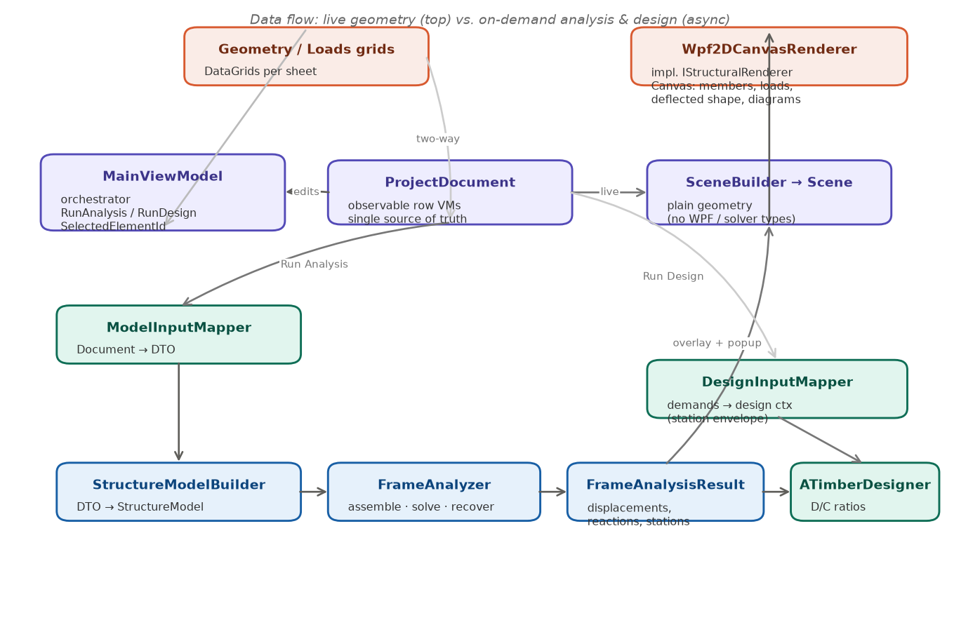
Figure 2 — Data flow: live geometry (top) vs. on-demand analysis and design (async).
Three execution paths share the same document:
- Live geometry, every edit to ProjectDocument raises a change event; MainViewModel rebuilds a Scene through SceneBuilder, and the renderer redraws. No solving occurs.
- On Run Analysis, ModelInputMapper snapshots the document to a plain DTO on the UI thread, then StructureModelBuilder + FrameAnalyzer run on a background thread and return a FrameAnalysisResult. The result feeds the deflected shape overlay and the diagrams popup.
- On Run Design, DesignInputMapper turns the analysis demands (the per-member station envelope) plus the design settings into a design context that ATimberDesigner checks.
Two boundaries keep the layers decoupled: the mappers (Document ↔ solver DTO) and the Scene (the renderer only ever sees plain geometry, never solver types or WPF types). Swapping the 2D canvas for a 3D renderer means writing a new IStructuralRenderer and a 3D SceneBuilder; nothing upstream changes.

Design patterns used

Pattern | Where | Purpose
MVVM | MainViewModel, row VMs (CommunityToolkit.Mvvm) | Separate state/commands from the WPF views; enables testing the UI logic without WPF.
Observer | ProjectDocument : IDocumentChangeNotifier; ObservableObject | One aggregated Changed event drives the live re-render from a single place.
Adapter / Mapper | ModelInputMapper, DesignInputMapper | Translate the UI object model to the solver/design DTOs at a single boundary.
Bridge / isolation | IStructuralRenderer + Scene | Decouple presentation geometry from the drawing technology (2D→3D swap).
Dependency injection / composition | FrameAnalyzer composes its services | Each step (assembly, solve, recovery, validation) is an injected collaborator which means testable and replaceable.
Strategy | ILinearSolver; per-code design provider; load-combination generators | Swap the algorithm (solver, design code, combination set) without touching callers.
Template Method / polymorphism | StructuralElement2D ← FrameElement2D, TrussElement2D | Shared element interface; each type supplies its own stiffness/transform.
Interface segregation | ILoad / INodalLoad / IMemberLoad; ITimberDesignCheck | Loads and design checks are small, focused contracts with many implementations.
Factory | TimberDesignCheckInputFactory; AnalysisService.CreateDefault | Build the right per-code check inputs / a fully wired analyzer.
Service layer (async) | IAnalysisService, IDesignService | Wrap the heavy engine calls behind async, non-crashing services.
Attached behavior | DoubleClickCommand | Bind a double-click to a command inside a DataTemplate (where InputBindings can't).

The Analysis Engine
FrameAnalyzer is an orchestrator built by composition: it holds the DOF numbering, stiffness assembly, load-vector and settlement builders, the linear solver, and the recovery services, plus the model validator. Calling Analyze runs validation, assembles and solves the system, then recovers displacements, reactions, element end-forces, and the per-member station results (section forces + deflected shape).
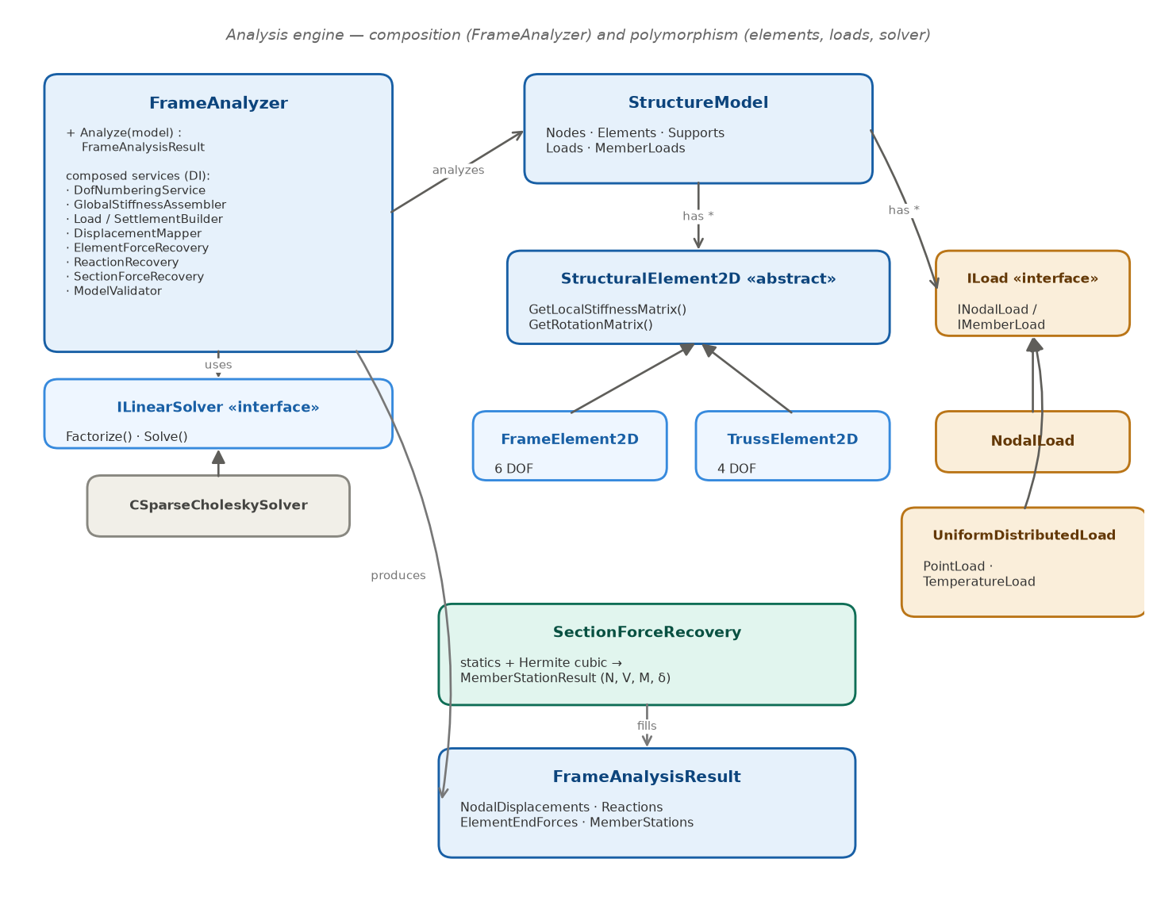
Figure 3 — Analysis engine: composition (FrameAnalyzer) and polymorphism (elements, loads, solver).
- StructureModel aggregates nodes, elements, supports, and loads, a plain object graph.
- StructuralElement2D is the abstract element; FrameElement2D (6 DOF, bending + axial) and TrussElement2D (4 DOF, axial) provide their own stiffness and rotation matrices.
- Loads implement ILoad / INodalLoad / IMemberLoad, so the assembler and recovery treat nodal loads, UDLs, point loads, and temperature loads uniformly.
- ILinearSolver hides the numerical backend (CSparseCholeskySolver), so the solver can be replaced without touching the analyzer.
- SectionForceRecovery samples N, V, M and the Hermite deflected shape at station points and fills FrameAnalysisResult.MemberStationsm, the single source of truth for the diagrams, the deflected overlay, and the design envelope.

5. The design module
The design module checks each member against a timber code. ATimberDesigner orchestrates the checks: it asks a provider for the per-code set of checks, asks a factory to build their inputs, orders them by their declared dependencies, and runs them (independent checks in parallel). The code (EC5 / TR / US) selects which concrete checks and inputs are used, a Strategy chosen by eTimberCode rather than by subclassing the designer.
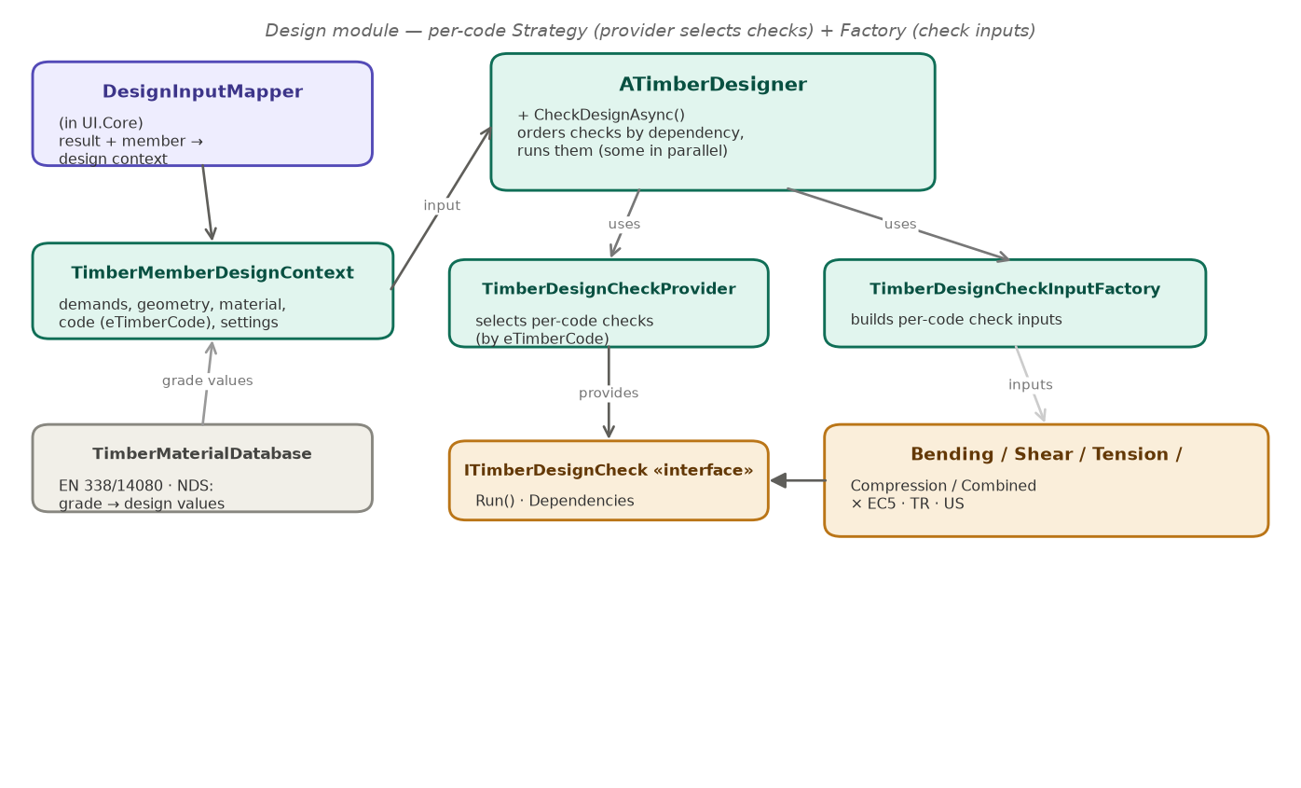
Figure 4 — Design module: per-code Strategy (provider selects checks) + Factory (check inputs).
- DesignInputMapper (in UI.Core) bridges the analysis result + the member parameters into a TimberMemberDesignContext, using the per-member station envelope for the demands.
- TimberMaterialDatabase supplies the published strength values (EN 338 / EN 14080, NDS species + grade) so picking a grade auto-fills the design values.
- Each check (bending, shear, tension, compression, combined) implements ITimberDesignCheck and exists in EC5, TR, and US variants.

6. Major design decisions
Decision | Choice | Rationale
Project split | FrameAnalysis.UI.Core (no WPF) vs FrameAnalysis.UI (WPF) | Makes “no WPF in the model/logic” a compile-time guarantee and lets the tests run the UI logic without WPF.
Source of truth | ProjectDocument (observable VMs); DTO only at the solver boundary | Grids bind to live row VMs; cross-row links are object references, so insert/delete/reorder stay safe.
Renderer input | A plain Scene; no solver or WPF types in the interface | Decouples the drawing technology; a 3D renderer is a new IStructuralRenderer + SceneBuilder.
Live vs on-demand | Geometry re-renders on every edit; analysis/design run on explicit buttons, async | Keeps the UI responsive; heavy work never blocks the UI thread.
Threading | Map document → DTO on the UI thread, then Task.Run the build + solve | The non-thread-safe document is never touched from the background task.
Error handling | Never crash: catch StructuralAnalysisException, surface ValidationMessages | An unstable/under-restrained model is explained, not thrown.
Design-code location | In the design layer (project-level), not global setup | Analysis stays code-agnostic; grade values are code-family specific, so one code per project keeps them coherent.
Identifiers | Implicit, sequential, assigned at export by the mapper | Raw table indices are never exposed; a stale id can’t corrupt the export.
3D readiness | Keep the hidden Z column; the renderer interface enables a UI swap | The solver stays 2D, but the architecture does not block a future 3D view.
Post-processing | Station recovery lives in the engine, on the result | One set of section forces feeds the diagrams, the deflected overlay, and the design envelope.
Deflected shape | Hermite cubic interpolation from the nodal end DOFs | Matches beam theory and needs only the displacements + rotations the solver already returns.
MVVM library | CommunityToolkit.Mvvm | Source-generated ObservableObject / RelayCommand with no WPF dependency.

7. Testing
Correctness is locked by an xUnit suite (88 tests) that verifies stiffness assembly, element behaviour, boundary conditions, and result recovery against closed-form solutions (e.g. cantilever and simply-supported beams), plus the mappers, services, and design checks. A separate verification document compares the program against these reference solutions in detail.

1. The application window
The window is split into two panes:
+-------------------------------+--------------------------------------------+
| MENU BAR | TOOLBAR |
| Geometry Loads Analysis | [Run Analysis] [Run Design] |
| Units Design | [Zoom Extents] Deflection x [ 1 ] |
| | |
| [Add Row] (Delete to remove) | |
| +-------------------------+ | (model viewer / canvas) |
| | active input sheet | | nodes . members . supports . loads |
| | (a data grid) | | deflected shape . reactions |
| +-------------------------+ | |
+-------------------------------+--------------------------------------------+
- Left pane — input. A menu chooses which sheet is shown; each sheet is a data grid for one part of the model (nodes, elements, loads, …). Only one sheet is visible at a time.
- Right pane — viewer. A live 2D picture of the model. It redraws automatically as you type. After an analysis it also shows the deflected shape and support reactions.

Canvas controls
Action | Control
Zoom | Mouse wheel
Pan | Right-mouse drag
Select a member | Left-click it (highlights orange)
Fit model to view | Zoom Extents button

[Screenshot suggestion: the full window with the sample portal frame loaded.]

2. Units and sign conventions
Units are shown in each grid's column headers. The defaults are:
Quantity | Unit
Node coordinates X, Y | m
Section width, depth | mm (see the Sections header)
Moment of inertia I | mm⁴
Material modulus E, strengths | MPa
Density ρk | kg/m³
Forces (Fx, Fy, reactions) | kN
Moments (Mz) | kN·m
Distributed load intensity | kN/m
Effective lengths (design) | m

The Units menu opens a sheet where the display units can be changed.
Sign convention: global +X is to the right, +Y is up. A downward force is therefore a negative Fy; a gravity (downward) distributed load is a negative intensity with direction Y. A counter-clockwise moment Mz is positive.

3. Building a model
A sample portal frame is loaded automatically on launch, so you always have something to explore. To build your own, work top-to-bottom through the Geometry and Loads menus.
On every sheet, use the Add Row button to append a row, edit the cells in place, and press Delete on a selected row to remove it. Rows that reference other rows (an element's start node, a load's element, …) use drop-down pickers, so you never type raw ID numbers — reordering or deleting rows stays safe.

3.1 Geometry ▸ Nodes
One row per node. Enter X and Y (m). IDs are assigned automatically.

3.2 Geometry ▸ Materials
Strengths are in MPa. Choose a strength class (e.g. C24 for EC5/TR) or a species/grade (US); the design values and the elastic modulus auto-fill from the built-in database. Tick Override to type values by hand.

3.3 Geometry ▸ Sections
Enter Width, Depth, and I (moment of inertia about the in-plane bending axis). Area is computed for you. For a rectangle, I = width · depth³ / 12.

3.4 Geometry ▸ Elements
One row per member. Pick Start node, End node, Material, and Section from the drop-downs. Type is Frame (bending + axial) or Truss (axial only). Release adds an end moment hinge (None, Start, End, or Both).

3.5 Geometry ▸ Supports
Pick the Node, then tick the restrained DOFs: Ux, Uy, Rz. The renderer picks the glyph automatically — pin (Ux+Uy), roller (one translation), or fixed (Rz too).

3.6 Loads
Each load type has its own sheet under the Loads menu:
- Joint Loads — nodal Fx, Fy (kN), Mz (kN·m) at a node.
- Distributed Loads — a uniform load on an element: intensity (kN/m) and direction (X or Y). Downward gravity = negative intensity, direction Y.
- Point Loads — a concentrated load at a distance along an element.
- Settlements — a prescribed support displacement.
- Thermal Loads — a temperature change on an element.
Each load carries a Nature (Dead, Live, Wind, …) used later by the load-combination generator.

4. Running the analysis
- Click Run Analysis (viewer toolbar). The solve runs on a background thread; a "Running…" indicator shows while it works.
- The viewer adds the deflected shape (dashed purple curve) and the support reactions (green arrows / moment arcs).
- Open Analysis ▸ Summary to see the result tables.
The program never crashes on a bad model: if the structure is unstable or under-restrained, the Messages list on the Summary sheet explains the cause instead.
If you edit the model after solving, the results become stale — a warning banner appears and the deflected overlay is dropped. Click Run Analysis again to refresh.

5. Reading the results

5.1 Summary sheet
Analysis ▸ Summary shows:
- Members — the element list. (Double-click a member here → see §5.3.)
- Reactions — Node, Fx [kN], Fy [kN], Mz [kN·m] at each support.
- Messages — warnings/info (e.g. static indeterminacy notes).

5.2 Deflected shape on the canvas
After a run, the canvas overlays the deflected shape. Because displacements are tiny, use the Deflection × box in the toolbar to exaggerate them (e.g. 50, 100, 500). The curve is the true bending shape (Hermite cubic interpolation of the nodal displacements and rotations), not just straight lines between displaced joints.

5.3 Internal-force diagrams (per member)
On the Summary sheet, double-click a member in the Members list. A popup opens with four stacked plots for that member:
- Deflected shape
- Normal force N (kN) — tension positive
- Shear V (kN)
- Moment M (kN·m) — sagging positive
Each plot draws the member axis as a horizontal baseline with the value plotted (and filled) to one side, auto-scaled so the shape is always visible. Under a distributed load the moment is the expected parabola; a point load shows the shear step and the moment kink.
[Screenshot suggestion: the member-results popup for the rafter of the worked example.]

6. Timber design checks (optional)
The Design menu runs code-based member-design checks against the analysis demands.
- Design ▸ Project Details — choose the design code (EC5, TR, or US) and the code-aware settings (service class / moisture condition, load-duration class, factor overrides).
- Design ▸ Materials — assign each material a strength class/grade so the design values are defined.
- Design ▸ Member Design — per member: effective lengths (major/minor/beam, in m), lateral support, etc.
- Click Run Design (enabled once an analysis result exists; demands are taken from it).
- Design ▸ Design Results — the demand/capacity (D/C) ratio for each member and check, coloured by status.
Design demands are taken from the station envelope of each member (the worst section force anywhere along the span — e.g. the mid-span moment under a UDL, not just the end values).

7. Complete worked example — timber portal frame
This is the model loaded on launch (Portal Frame (sample)), so you can follow along immediately, or rebuild it from scratch with the steps below.

7.1 The structure
A 4 m × 3 m fixed-base timber portal: two columns and a rafter (beam), a lateral load at the left eaves and a gravity UDL on the rafter.
w = 8 kN/m (down)
| | | | | | | |
v v v v v v v v
N2 *================* N3 Nodes (m): N1(0,0) N2(0,3) N3(4,3) N4(4,0)
-> | (E2 rafter) | Elements: E1: N1->N2 (col)
8kN | | E2: N2->N3 (rafter)
| E1 E3 | E3: N4->N3 (col)
| | Supports: N1, N4 fixed (Ux,Uy,Rz)
### N1 ### N4
(fixed) (fixed)

7.2 Input
Item | Value
Nodes | N1 (0, 0), N2 (0, 3), N3 (4, 3), N4 (4, 0) [m]
Material | Timber C24 (E ≈ 11 000 MPa, auto-filled from the class)
Section | 150 × 300 mm, I = 150·300³/12 = 3.375×10⁸ mm⁴
Elements | E1 N1→N2, E2 N2→N3, E3 N4→N3 — all Frame, release None
Supports | N1 and N4: Ux, Uy, Rz all restrained (fixed)
Joint load | N2: Fx = +8 kN (lateral, →)
Distributed load | E2: −8 kN/m, direction Y (gravity, down)

To build it by hand: add the four nodes, one C24 material, the 150×300 section, the three elements, two fixed supports, the joint load, and the distributed load — in that order.

7.3 Run and read
- Run Analysis. The frame sways slightly to the right (lateral load) and the rafter sags. Set Deflection × to ~100 to see it clearly.
- Analysis ▸ Summary → the Reactions table lists the base reactions at N1 and N4.
- Double-click E2 (the rafter) in the Members list → the popup shows its deflected shape, the near-constant axial, the linear-then-stepped shear, and the parabolic moment from the 8 kN/m UDL.

7.4 Sanity checks (hand verification)
These equilibrium checks should hold for the reactions in the Summary table:
- Vertical: the only vertical load is the rafter UDL, 8 kN/m × 4 m = 32 kN down. → the two vertical base reactions must sum to +32 kN (up).
- Horizontal: the only horizontal load is the 8 kN joint load (→). → the two horizontal base reactions must sum to −8 kN (i.e. 8 kN total pushing back, ←).
- Moment: the sum of base moments and the moments of all reactions/loads about any point must be zero.
The program also runs an internal equilibrium-residual check and reports a warning if ‖K·U − F‖ is large, so a clean run with these totals confirms the solution.

7.5 Design (optional)
Open Design ▸ Project Details, choose EC5, confirm the material is C24, then Run Design. Design ▸ Design Results lists each member's D/C ratio; the sample is sized to pass with a sensible margin.

8. Troubleshooting
Symptom | Cause / fix
Double-clicking a member does nothing | Run an analysis first; the popup needs a current result.
"Results are out of date" banner | You edited the model after solving — click Run Analysis again.
Deflected shape looks flat | Increase Deflection ×.
A red error in Messages | The model is unstable / under-restrained; the message names the node or DOF at fault.
Run Design is disabled | Run an analysis first (design demands come from it).
Nothing on the canvas | Use Zoom Extents, or check that elements have both end nodes assigned.

